**Guidance Document for DNDCv.CAN parameters**

**--------------------------------------------------Climate TAB------------------------------------------**

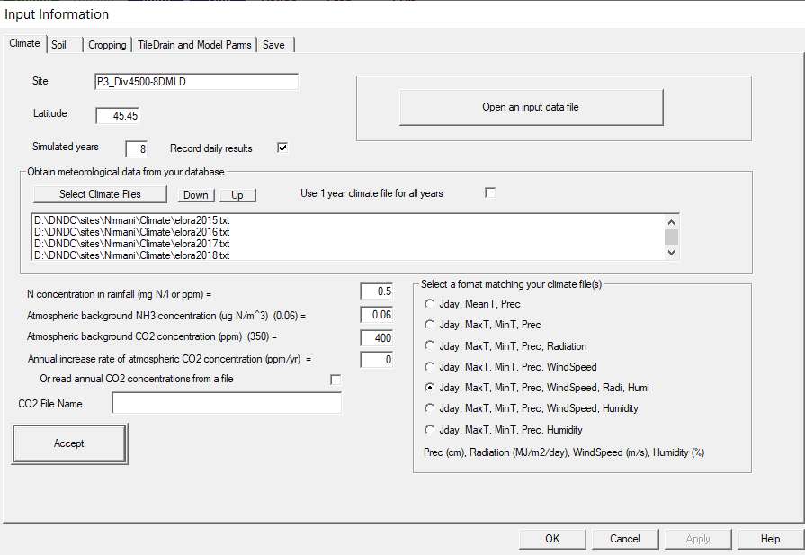

1. 

This is the Site Name. It should not contain spaces. Use underscore if necessary.

1. 

Latitude of the site. Used for Penman Monteith calculations for Evapotranspiration.

1. 

Total Simulation Time (including spinup). Record daily results Yes/No. If no will only generate the annualized output files (multi_year_summary.csv and multi_year_water.csv

1. 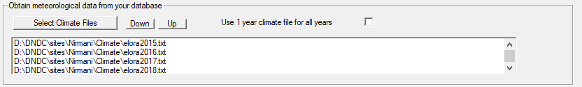

Path location to Daily Climate files. Can either use a single year of daily climate for all simulation years (Step 3.) or must have a file for each simulation year.

1. 

Wet Deposition of N in rainfall. Usually use range of 0.5 – 2.5 (relative of rainfall amounts it corresponds to ~5-15kg N/ha/y deposition). Typically start with a value of 0.5. Higher values will influence denitrification N2O peaks as it corresponds to N being supplied on the soil surface during wetting events.

1. 

Dry deposition of ammonia. Typically higher values used in regions near Industry or feedlots. Values used are 0.06 – 1.5 . Typically use 0.06. Used directly by plant to meet N uptake requirements during season.

1. 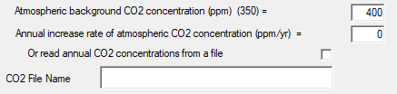

Background CO2 ppm. Can be run at a fixed amount or increased at a fixed rate or read in from a file for varying increase rates. See Mulit_Year_AIRCO2.txt file for example.

1. 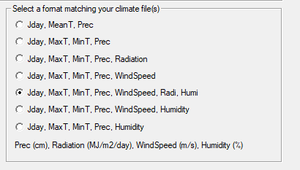

Specifies the expected format for Climate files and elements contained within the climate file. Units specified at bottom. The model operates better with all elements provided otherwise general estimates of Potential Evapotranspiration are calculated using fixed estimates of windspeed, RH etc.

**-----------------------------------------SOIL TAB-----------------------------------------------**

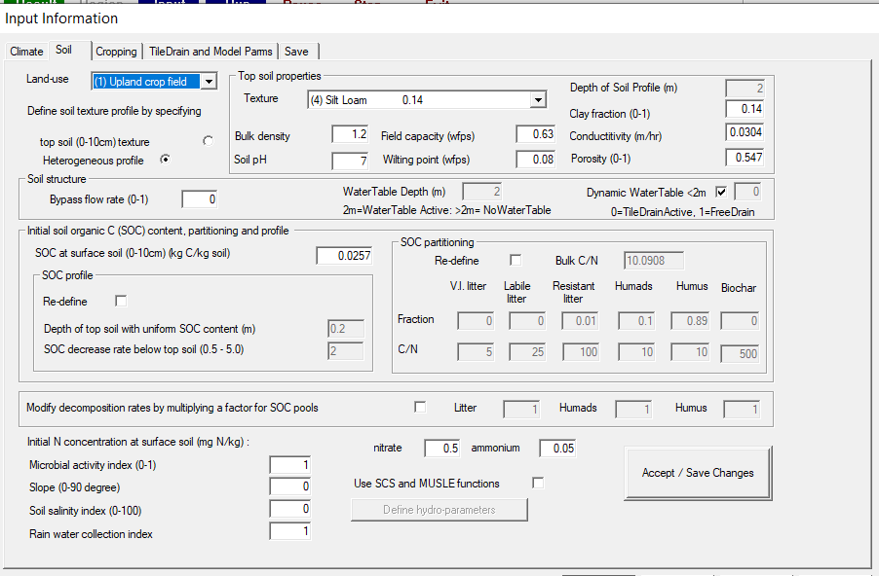

1. 

Land use type. Typically select upland cropping system for agricultural cropping systems.

1. 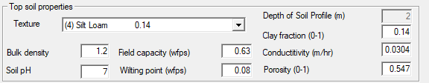

Soil properties defined. Soil Texture selection defines general soil properties that can be further modified with inputs (defaults pulled from library directory). For a homogeneous soil profile these characteristics are applied to the top soil profile and distributed across depth using a simple exponential function for Bulk Density and porosity. With a heterogenous profile the soil properties in the heterogenous file are used to determine the soil characteristics. Note the Sat Conductivity has a minimum value of 0.015. Porosity should be cacluated using Porosity = 1 – bulkDensity/2.65. Field Capacity and wilting point are in WFPS not volumetric units. Clay fraction is hard coded not to exceed 60% internally and uses Saxton pedotransfer functions internally to calculate a Ksat value.



**Bypass Flow rate** specifies the water that bypass the entire soil profile. 0 = no bypass flow. 1= full bypass flow. Typically run with a value of 0.

**WaterTable Depth** is automatically populated based on the selection of Dynamic Water Table option. A value of 2 indicates that the boundary condition is closed at the 2m depth and a dynamic water table is being simulated. A value of 2.5 indicates free drainage condition out the 2m depth.

**Dynamic WaterTable** used to simulate the presence of a dynamic water table from 2m to surface. Normally indicates the presence of tile drainage to cope with water table. Tile Drainage characteristics are specified in TileDrain and Model Parms Tab. Can use engineering documentation such as (<https://fyi.extension.wisc.edu/drainage/files/2015/09/Basic_Eng_-Princ-2_2017.pdf>) to determine appropriate tile specifications. Tile Drainge is calculated using Hooghoudt’s drainage equation. Normal simulations are without a dynamic water table/tile drainage. Poorly drained soils can be simulated by using a poorly engineered tile setup for tile drainage (extra wide spacing, deep tile placement, small diameter).

1. 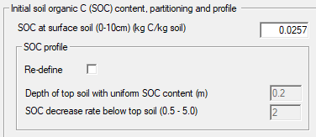

**SOC at surface soil (0-10cm)** specifies the organic carbon concentration in the top soil profile. This value is important for determining the size of the Humus, Humads fractions and is extrapolated down through the profile at a decreasing rate. If a heterogeneous soil profile is used then this value should reflect the surface profile of that file.

**SOC profile –** Can be used to redefine the homogenous portion of SOC content to another depth. The decrease rate for SOC is used to determine how fast SOC decreases with depth. **Normally do not adjust.**

1. 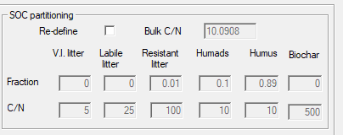

This is used to define the SOC pools and bulkd C:N ratio. Humus and Humads fractions are automatically determined using the initial SOC content. Can be redefined to specify the passive fraction size (HUMUS). A higher HUMUS value will result in slower mineralization of SOC and less available mineralized N. Normally we simulate HUMUS factions between 0.8 – 0.95. **Start with default values and only modify if necessary.**



These parameters are used to modify the base rates of decomposition for the various SOC pools. Values <1 indicate slower than default values and >1 represents decomposition rates faster than default values. Normal range of modification lead to values between 0-5. **Only modify if necessary. Normally simulate using default values.**

1. 

These values can be ignored as the recommended spinup years (1-5 years) will initialize the nitrate and ammonium concentrations for the investigated period appropriately.

1. 

Used for simulating polluted soils. Normal soils should use a value of 1.

1. 

Slope of soil. Used to determine the water runoff either via SCS curve method or via empirical calculation. Normally run with 0 slope.



Leave default values.

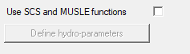

1. SCS curve method used to estimate runoff based on soil conditions.

**------------------------------CROPPING TAB-------------------------------------------**

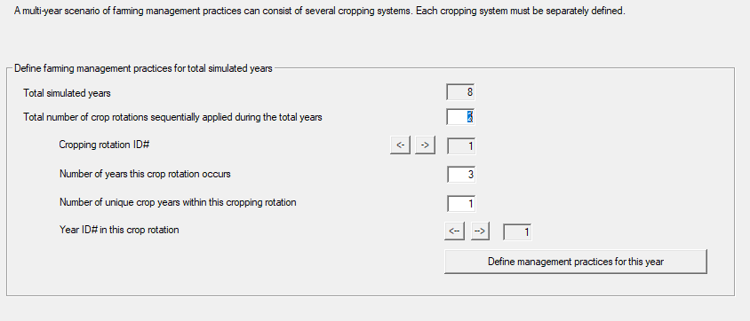

1. 

This determines the number of unique rotation time blocks that you want to define in DNDC. So if you wanted to have Corn-Soybean rotation and a Corn-Corn-Alfalfa-Alfalfa rotation then you would want to define Crop rotations as 2. Normally we’d define a minimum of 2 blocks (1 for your spinup rotation and 1 for your investigative period). Note that rotation time blocks should ideally be limited to less than 20 total years.

1. 

Crop Rotation ID# is the rotation ID identifier based on the number of rotation blocks you defined in step 1.

1. 

This is to define how long in years the current rotation ID spans over the total simulation years span. In this case it would span 3 of the 8 years. 

1. 

This is to define your rotation length for each defined rotation block. For instance a Corn-Soybean Rotation would have a rotation length of 2. Limit this to lengths less than 20 years. In this case the rotation length is 1 year that repeats for 3 years.

1. 

This corresponds to identifying and allowing the user to define unique management to each year of the rotation defined in Step 4. This value is automatically defined based on the value in STEP 4.

1. 

This button facilitates the opening of the Farming management tab to define unique management for each crop rotation year.

**--------------Farm Management Practices Tab----------------**

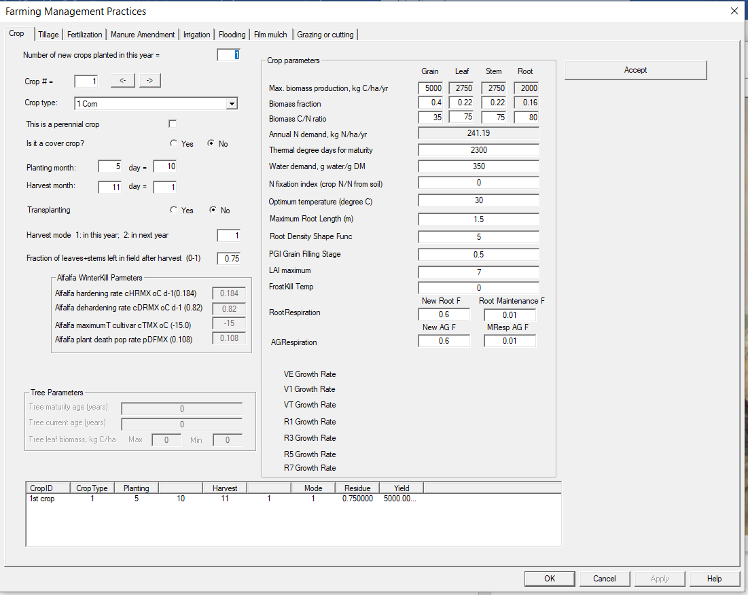

1. 

Define the number of crops that will be planted in the current year. Fallow does not require planting. A maximum of 7 crops can be concurrently planted however we normally would recommend planting as few as possible when (for example) a grass species is composed of multiple crop types.

1. 

This allows the user to cycle through each defined crop in Step 1.

1. 

Define the crop type to be planted. The default crop parameters are pulled from library directory however significant scrutiny should be placed to ensure that the crop parameters are representative of the crop being planted. These values tend to vary greatly between cultivars and should be changed for a simulation to calibrate them to the location.

1. . Flag for perennial crops. If flagged the crop will continuously grow from year to year and does not need to be reseeded the following years. Should only be flagged for perennial grasses typically. Perennials can only be terminated using a terminating tillage event in the tillage operations.
2.  This allows the crop to continue overwinter without being killed by freezing temperatures.
3. 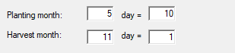

Defines the planting and harvest timing. Note that since DNDC does not operate with consideration of LEAP years that these dates might be offset in LEAP years compared to observations.

1. 

Used for RICE. Ignore otherwise.

1. 

This will be flagged to 2 when the crop growth spans over Dec 31st to the next year.

1. 

The fraction of above ground /non harvested residues that are returned to the field after a harvest event as residue. This residue will be subject to decomposition and will eventually reach the surface soil pools.

1. 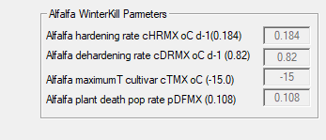

These are Alfafa specific parameters used for Alfafa winterkill survival calculations based on the ALFACOLD model. Winterkill incidence will eventually diminish the ALFALFA stand to a point where ALFALFA will require replanting. Can be parameterized to have no effect of winterkill.

1. 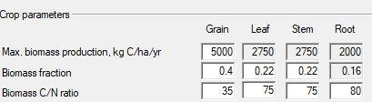

These parameters are use to define the current crop. Max biomass production kg C/ha/y defines the cultivar genetic potential for the crop if zero stress is experienced (no temperature, water, nutrient stresses). Note that these values are defined in kg C and should be converted to moisture harvest (typically by dividing by 0.4) to approximate ~13% moisture and divide by 0.45 to approximate dry weight productivity ~ 0% moisture.

1.  Determined by the C:N ratio and biomass production and plant fractions. This represents the maximum N demand required to reach maximum biomass production. The user should anticipate that the bulk of this N demand will need to be sourced from N inputs (Fertilizer, Manure, N-fixation) and will be supplemented in part by mineralization.
2. 

Thermal degree days are the heat units required for the crop to reach harvest maturity. This is calculated based on a average degree days calculation of mean daily temperatures above 0oC.

1. 

Defined as the amount of water the crop requires for transpiration to produce 1g/Dry matter. This value isn’t absolute and should be treated more as a relative water demand metric. Leaf Area Index maximum is also relevant to increasing this influence. Typically the minimum value for WREQ is ~100-250 for most small grains (wheat, canola) and the maximum value is ~350-450 (soybean).

1.  Determines what level of N fixation the crop has. 0= no N fixation capabilities. 1= Full N demand requirements met by N fixation. Alfalfa =0.5 typically and Soybean = 0.5-0.7 N fixation. The NFixation routine is also influenced by the amount of residual soil N in the rooting depth (higher values of residual soil N lower N fixation amounts) and soil temperature (lower temperatures reduce N fixation).
2.  Used to determine the optimal temperature for crop productivity. Overwintering crops usually are set with values 14-18. Cool season crops 19-23C. And warm season crops 25-30.
3. 

This sets the maximum root length for the crop to extract water and nutrients from the 2m profile. This value can be influenced by soil texture. Fine textured soils will root shallower than coarse textured soils. Maximum rooting depth is typically achieved partway through the vegetative growth of the plant development.

1. 

Determines the Root density shape of the roots. A value of 1 is linearly distributed across depths where a value of 8 puts a higher weighting of root mass towards the surface and lower distribution at depth. Normally we use values of 3-5 for root shape.

1. 

Sets the grain filling PGI stage (plant growth index 0-1) for when grain filling initiates. Minimum value of 0.5 and Maximum value of 0.75. The crop growth model is split into two stages primarily vegetative growth PGI 0-0.5 and Reproductive growth 0.5-1.0.

1. 

This determines the maximum LAI value that is reported by DNDC for the crop. Used to calculate actual transpiration demand along with WREQ (Step 14.). Note that LAI is determined in DNDC from a relationship of aboveground biomass à Leaf biomass à LAI. LAI is not determined using photosynthetic efficiency approaches.

1. 

Currently inactive but will be used to determine the temperature which stops growth permanently. Normal values would be 0 to -7 oC.

1. 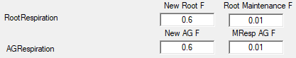 New parameters for modifying the Root and AboveGround CO2 Respiration magnitude for New Growth and Maintenance Respiration. New Growth Ranges between 0.2-0.8 and 0.01 – 0.0001 for Maintenance Respiration.

**-----------------------------Tillage TAB------------------------------**

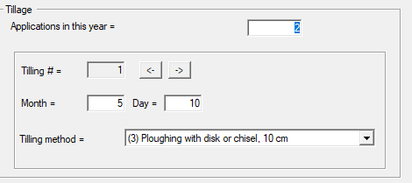

1. Applications in the year is to define the number of tillage events that occur in the year. Tilling # is the tillage event ID and is used to cycle between tillage events. There are 7 options for tillage events and most are pretty straightforward. The only unique ones are Buried Tillage which flips the residue topsoil and burries it to the plough depth. This essentially puts the higher input C into the deeper profile at 20-25 cm to protect it from quick decomposition. And Terminating Tillage is the option used to kill perennial defined crops.

**----------------------------------------Fertilizer Tab---------------------------------**

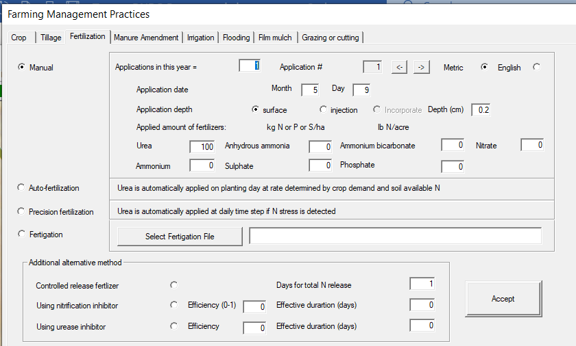

1. 

Radio Button Manual determines manual application of Fertilizer event (versus the model automatically determining fertilizer rates). Applications in this year is meant to define the number of fertilizer applications for the current year. Application # is the ID number for a the defined number of applications. Metric or English units of fertilizer buttons. Typical fertilizer events should be defined as manual.

1. 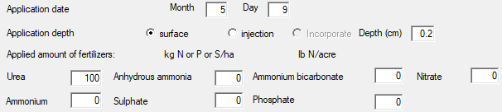

User defined Application Date. Month and Day are defined here.

Application depth (surface or injection). Surface Broadcast (ammonia based fertilizers will be subject to high potential NH3 volitilization) or banded to a depth specified by the user. Immediate incorporated of fertilizer is currently not a option but can be replicated by splitting the fertilizer application into multiple applications over increasing depths to simulate the incorporation distribution of fertilizer. Note that the Nitrogen is the only fertilizer component that needs to be entered into the fertilizer routine. Phosphorus and Sulphates are not actively simulated by the model at this time.

1. 

See CANADA DNDC user guide for more information. Autofertilization allows the user to define the application date (above in manual fertilizer section for up to two applications) at a rate determined by the model using a spring soil test N approach. The model will try to approximate the appropriate N rate for the upcoming season based on the past 10 years of crop nutrient stress.

1. 

Precision fertilizer applies N each day to meet the daily crop nutrient demands. Not recommended in most investigations as this tends to be unrealistic in the application of nitrogen and will often result in large Trace Gas emissions.

1. 

Allows fertilizer to be added with irrigated water.

1. 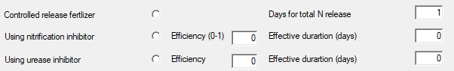

For Enhanced Efficiency Fertilizer Products.

Controller Release Fertilizer. Yes/No. This will slowly release the manually defined fertilizer linearly over the Days for total N release. This is an imperfect representation of slow release fertilizer as it would be better to use soil moisture/temperature effects on degradation of the slow release capsule to dictate N availability. Nitrification and Urease Inhibitors can be defined as additives for manual fertilizer that will dictate their efficacy and duration. Normally we utilize efficiency of products in the 0.9 – 1.0 range and durations of (10-20 days for urease and 30-55 days for nitrification products).

**--------------------MANURE Amendment TAB--------------------------**

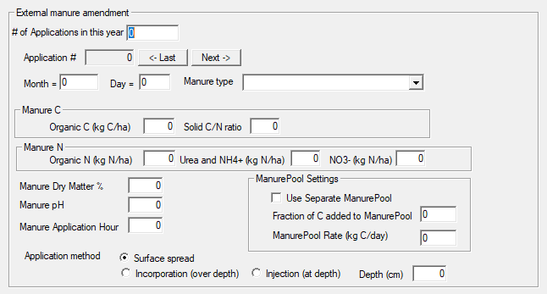

1. Section to be finalized. Defines Manure Application, Manure Application Type, Manure Constituients, Application method and if to use a separate Manure C pool (separate from soil C pools) to emulate Manure Decomposition (using user defined rates of decomposition).

**---------------------** **TileDrain and Model Parms Tab-------------------------------**

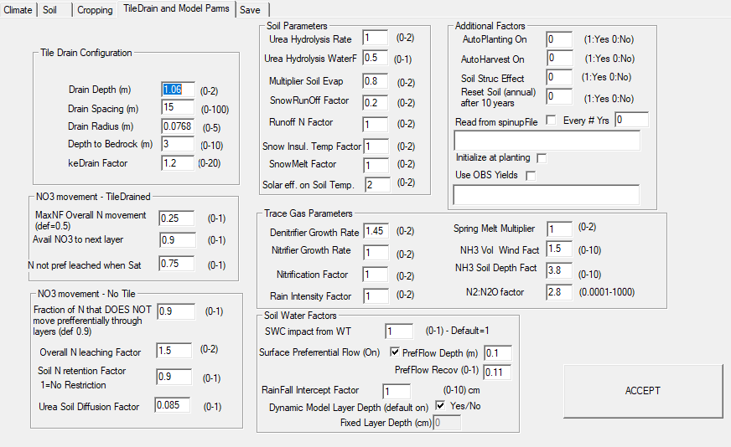

1. 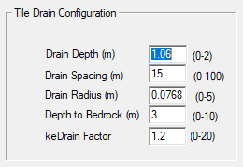

TileDrain Engineering Specifications. Used by Hooghoudts equation. Should refer to engineering documents (<https://fyi.extension.wisc.edu/drainage/files/2015/09/Basic_Eng_-Princ-2_2017.pdf>) to determine appropriate specifications for tile drainage depth, spacing , diameter. Typical values for Depth (0.6-1.1 m), Drain Spacing (15-40), DrainRadius 0.06-0.10, Depth to Bedrock 3, keDrainFactor 0.8 – 1.8 (determines lateral flow rate to drains). Note these values are only required if dynamic water table is defined in the soils tab of the model.

1. 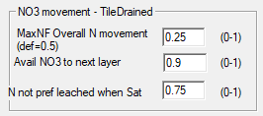

Allows the user to specify the mobility of N in tile drained situations with a dynamic water table. These are calculated on an hourly time step in the water delivery component of the model. MaxNF = Overall nitrate mobility factor of soil layers above tiles that are being drained. (0.25 – 0.5 is typical values). Avail NO3 to next layer : On an hourly basis the fraction of the available soil Nitrate that can be mobilized to move to the next layer. (0.8-1.0 are typical values). N not pref leached when Saturated: Determines the Nitrate that doesn’t preferentially leach directly to the tiles when the soil is saturated in the current layer and all the layers below but also above the tiles. (Typical value of 0.75)

1. 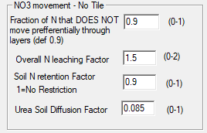

These parameters affect both Tile and Non-Tiled systems but are more relevant to NON-Tiled systems.

Fraction of N : That moves from layer to layer with water. 0.9 is default value. In this case a fraction of 0.1 of the N would move directly from a layer out the bottom of the profile when water movement between layers occurs.

Overall N leaching Factor: This determines the rate of N leaching. Typical values are between 1-1.5

Soil N retention Factor: A very small portion of N when N concentrations are very low in the soil layer can be set to become more difficult to mobilize using this factor. Results in the soil layer rarely becoming fully depleted of N. Typical valueof 0.9

Urea Soil Diffussion Factor: This is used to help Urea to diffuse slowly into the soil over time. In cases where urea hydrolysis is impeded by lack of water or by inhibitors there can be some diffusion processes that incorporate the urea deeper into the soil profile. A value of 0.085 would be quite quickly vs a value of 0.01 would be very minimal diffusion. This will impact NH3 emissions.

1. 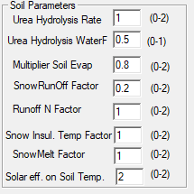

Urea Hydrolysis Rate: Typical value of 0.8-1.0. Influences the rate of urea hydrolysis. Lower values will slow hydrolysis.

Urea Hydrolysis WaterF: Sets the sensitivity of urea hydrolysis to moisture. Typical values of 0.5 is a good place to start.

Multiplier Soil Evap: Typical value of 1.0 to start but use range of 0.8-1.2 to calibrate.

SnowRunoffFactor: Default is 0.2. Controls the fraction of water that moves directly to runoff during snowmelt.

Runoff N factor. Default is 1.0. Can be used to modify the N moving from the surface layers directly to Runoff with water.

Snow Insul Temp Factor: Default is 1. Can be used to control the influence of snowpack on heat transfer between air and soil. Values >1 will increase snow insulation effect and Values <1 will decrease it. Typically run with a value of 1.

SnowMelt Fator: Default is 1. Controls the rate at which snowmelt occurs when maximum air temperature is above 0 oC.

Solar eff. On Soil Temp :Affects the heating effect of high solar radiation on surface soil temperatures. Values between 1.5-2.0 seem to work well however they should be verified when available with observation data. Note that crop albedo will reduce the impact of solar radiation heating when crop biomass becomes large.

1. 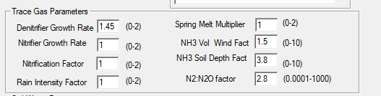

DenitiriferGrowth Rate: Controls the rate of microbial dentrifier growth. Most soils work well with values of 1.2-1.5. Typically start with values around 1.2

Nitrifier Growth Rate. Controls the rate of nitrifier growth. Typical values are run using values of 1. Since Nitrifiers operate in aerobic conditions their activity produces more of a constant background trace gas production. Lowering the value below 1 would lower this background emission rate.

Nitrification Factor: Controls the nitrification rate of ammonium to Nitrate. Typically start with values of 1 for most simulations.

Rain Intensity Factor: This is an empirical factor meant to compensate for the lack of prolonged saturated conditions in a tipping bucket hydrology model. Will produce sharp spikes of N2O emissions when rainfall events occur. Typical value is 1 but can decrease if rainfall peaks are too large.

Spring Melt Multiplier: Controls the effect of Spring Melt processes that determine spring burst emissions. It influences the amount of DOC that is generated from deep freezes that will aid denitrifier growth when spring melt occurs. Typical value for simulations is 1.

NH3 Vol Wind Fact: This controls the effect of Henry’s Law on NH3 volatilization. Very sensitive. Typical values of 1-3. Start with 1.5 and calibrate.

NH3 Soil Depth Factor: Influences the effect of soil depth on reducing NH3 volatilization potential. A higher value will increase the effect of soil depth on reducing emissions. Typically we use values between 2.5-4.0. A value of 3.0 is a good place to start. Note that the size of layer depth (see below) will influence this value as larger sized layers may require a higher Soil Depth Factor.

N2:N2O factor: Controls the proportion of N2 generated to N2O. Typical simulation start values of 2.5-3.0 work well. Can be calibrated if necessary.

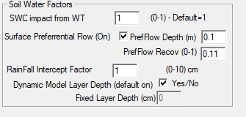

SWC impact from Water Table: If water table is turned on in soil tab then make sure this value is set to 1. Not used when no water table is being simulated. Lower values can be used to increase dependence on the water table to supply transpiration demand but it can cause problems if roots have not reached water table depth.

Surface Preferential Flow: Allows the user to turn on preferential water flow in surface layer. Partial Mechanistic approach that allows cracking to form in surface soil layers to allow water to bypass the top soil layers and move directly to layers below. I would only turn this on if you have measured soil water contents and notice that the soil dries out on the surface profile. Typically we apply this to the top 10 cm (0.1 value) and the PrefFlow Recovery is used to recover the soil from cracking when rainfall events occur. Typically use a recovery value of 0.1 (slow recover) vs 0.3 would be a fast recovery when rainfall occurs.

Rainfall Intercept Value: Determines the amount of rainfall that can be intercepted by crop leaves during maximum growth and evaporated without reaching the soil surface. Typically start with a low value of 1.

Dynamic Model Layer Depth: Can be turned on to run the model in default mode which automatically determines the layer depth size. Results in a large number of layers normally being simulated and can be more computationally intensive. Or use a Fixed User specified depth. I wouldn’t recommend a value larger than 2.5cm. Typical values for fixed layer depth of 1 – 2.5cm is appropriate.

1. 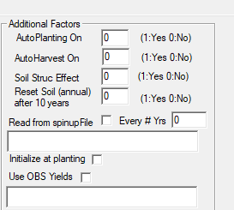

AUtoPlanting: Will calculate the planting date based on Bootsma and Dejong cool/warm species and soil trafficability factor. Works pretty well in situations where no planting date is available.

AutoHarvest: Will autoharvest the crop when crop reaches maturity. Can be used in climate change scenarios when harvest date is unknown.

Soil Struc Effect: Using Saxton Pedotransfer function the feedback of soil carbon concentration is used to shift the hydraulic conditions of the soil over time. As organic matter increases over time the holding capacity of the soil will improve. Recommend not using unless this feedback is needed.

Reset Soil (annual) after 10 year spinup. This allows the soil conditions to be automatically reset to the conditions after the 10 year spinup for each year moving forward. Basically it runs each year >10 like it is following the 10 year spinup.

Read from spinupFile (Yes/No), And every how many years (0=off, 1= every year etc). The spinup file is read into the model to reset the Jan 1st soil conditions every year. Can also be set to read in at time of planting.

Use OBS Yields: This can be employed to bypass the simulated yields and ensure carbon inputs are used that match observed values.